For each audiogram,

* State whether there is a hearing loss (yes or no). How can you tell?
* Does the audiogram have both air and bone conduction testing?
* If there is a hearing loss, is it “more moderate” or “more severe?”
* If there is a hearing loss, can you tell whether it’s conductive or sensorineural or mixed?
* If there is a hearing loss, is it unilateral or bilateral? Which ear is the better one/are there differences between the two ears?
* Is the hearing loss age-related?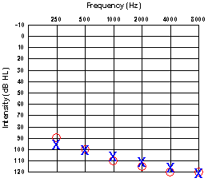
* Is hearing loss, can only hear frequency at high frequencies
* Yes
* More severe
* Conductive
* Unilateral, the left ear is a little bit better on average
* Hearing loss is not age related

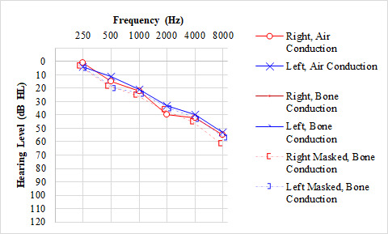

* State whether there is a hearing loss (yes or no). How can you tell?

Yes, at higher frequencies, they need a significant dB increase to be able to hear the frequencies

* Does the audiogram have both air and bone conduction testing?

Yes, it has both types of measurements

* If there is a hearing loss, is it “more moderate” or “more severe?”

More moderate

* If there is a hearing loss, can you tell whether it’s conductive or sensorineural or mixed?

Mixed, all of the reading are together

* If there is a hearing loss, is it unilateral or bilateral? Which ear is the better one/are there differences between the two ears?

Unilateral, there is a difference, the left ear is better than the right.

* Is the hearing loss age-related?
  + It looks age related, the higher frequencies taper off

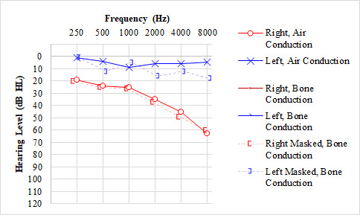

* State whether there is a hearing loss (yes or no). How can you tell?

Yes, right ear has significant dB boost at high frequencies, left ear has normal hearing

* Does the audiogram have both air and bone conduction testing?

both

* If there is a hearing loss, is it “more moderate” or “more severe?”

More moderate but leaning on moderately severe in the higher frequencies

* If there is a hearing loss, can you tell whether it’s conductive or sensorineural or mixed?

Seems like sensorineural, both conductive and air conduction are having the same effect

* If there is a hearing loss, is it unilateral or bilateral? Which ear is the better one/are there differences between the two ears? bilateral hearing because one ear is better than the other
* Is the hearing loss age-related? no

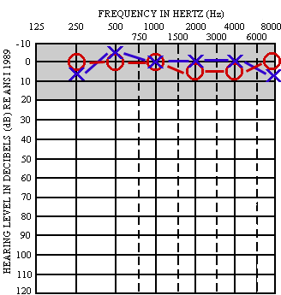

* State whether there is a hearing loss (yes or no). How can you tell?

No, the dB increase does not go over the threshold.

* Does the audiogram have both air and bone conduction testing?

No, Just air induced

* If there is a hearing loss, is it “more moderate” or “more severe?”

No hearing loss

* If there is a hearing loss, can you tell whether it’s conductive or sensorineural or mixed?

No hearing loss

* If there is a hearing loss, is it unilateral or bilateral? Which ear is the better one/are there differences between the two ears?
* No hearing loss
* Is the hearing loss age-related?
* There is no hearing loss